ISFA614 - Agentic AI Risk Assessment Workflow Orchestration
Submission Document

Group Name
Student Names

Submission Instructions
Attach the required output files generated from your completed n8n workflow. The submitted files must come from your own workflow execution and must match the customer data used for the final test run.
- Submit all five required outputs listed below.
- Do not rename the report contents or manually edit the CSV results after generation.
- For CSV files, attach the generated .csv file. For the management report, attach the generated .svg file.
- Embed the files in the word document, use Word: Insert → Object → Create from File → Browse → Display as icon.

Required Output Files
No. | Required Output | Expected File Type
1 | Agent-1 Customer Profile Risk Report | .csv
2 | Agent-2 Transaction Pattern Risk Report | .csv
3 | Agent-3 Regulatory Screening Risk Report | .csv
4 | Agent-4 Agentic AI Recommendation Report | .csv
5 | Agent-4 Management Risk Dashboard | .svg

Provide the output of all the agents report for the Dataset 0.

Agen-1 Report |  | Agen-2 Report
Double click  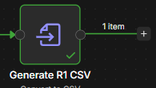  Click   | Attach R1_Customer_Profile_Risk.csv here | Double click  Click | Attach R2_Transaction_Pattern_Risk.csv here

Agen-3 Report |  | Agen-4 Report
Double click  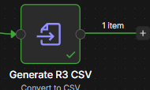  Click | Attach  R3_Regulatory_Screening.csv  here |  | Double click  Click | Attach R2_Transaction_Pattern_Risk.csv here

After completing all the 7 tasks
Agentic AI Risk Assessment Workflow Orchestration (JSON)
Produce the output of the workflow.
Go to  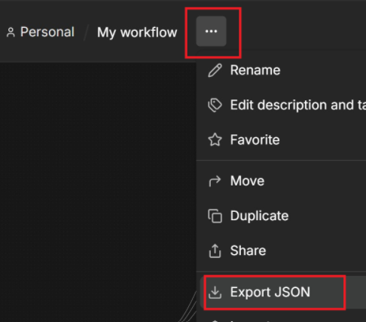 | Attach your <YourProject>.json here

Rerun the workflow for Dataset 1 and Dataset 2, and provide the reports generated by all AI agents for each dataset.

Agent-1 Report (.csv)
Provide the output of the Agent-1 Customer Profile Risk report.
Dataset 1 |  | Dataset 2
Double click  Click | Attach R1_Customer_Profile_Risk.csv here | Double click  Click | Attach  R1_Customer_Profile_Risk.csv here

Agent-2 Report (.csv)
Provide the output of the Agent-2 Transaction Pattern Risk report.
Dataset 1 |  | Dataset 2
Double click  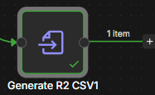  Click | Attach R2_Transaction_Pattern_Risk.csv here | Double click  Click | Attach  R2_Transaction_Pattern_Risk.csv here

Agent-3 Report (.csv)
Provide the output of the Agent-3 Regulatory Screening Risk report.
Dataset 1 |  | Dataset 2
Double click  Click | Attach  R3_Regulatory_Screening.csv here | Double click  Click | Attach  R3_Regulatory_Screening.csv here

Agent-4 Report (.csv)
Provide the output of the Agent-4 Agentic AI Recommendation report.
Dataset 1 |  | Dataset 2
Double click  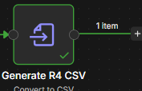  Click | Attach R4_Agentic_AI_Recommendation.csv here | Double click  Click | Attach  R4_Agentic_AI_Recommendation.csv here

Agent-4 Management Report
Provide the output of the Agent-4 Management Risk Dashboard.
Dataset 1 |  | Dataset 2
Double click  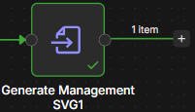 Click | Attach the screenshot of Management_Risk_Dashboard here | Double click  Click | Attach the screenshot of Management_Risk_Dashboard here

Agentic AI Risk Assessment Quiz
This quiz is designed to test your understanding of the key AI and Agentic AI concepts covered in the DXS Bank Risk Assessment Lab, including AI Agents, prompts, system messages, structured outputs, guardrails, hallucination, dynamic business rules, multi-agent systems, orchestration, and human oversight.
Instructions: Select the best answer for each question and provide a brief explanation to justify your choice.
Quiz Link: https://smu.sg/Agentic_AI

Member | Contribution  (Example: Tom contributed to developing Task1, Task 2 and Task 3.  Chan contributed to developing the Task 4, 5 and 6)
Name1
Name2

Briefly explain your learning

